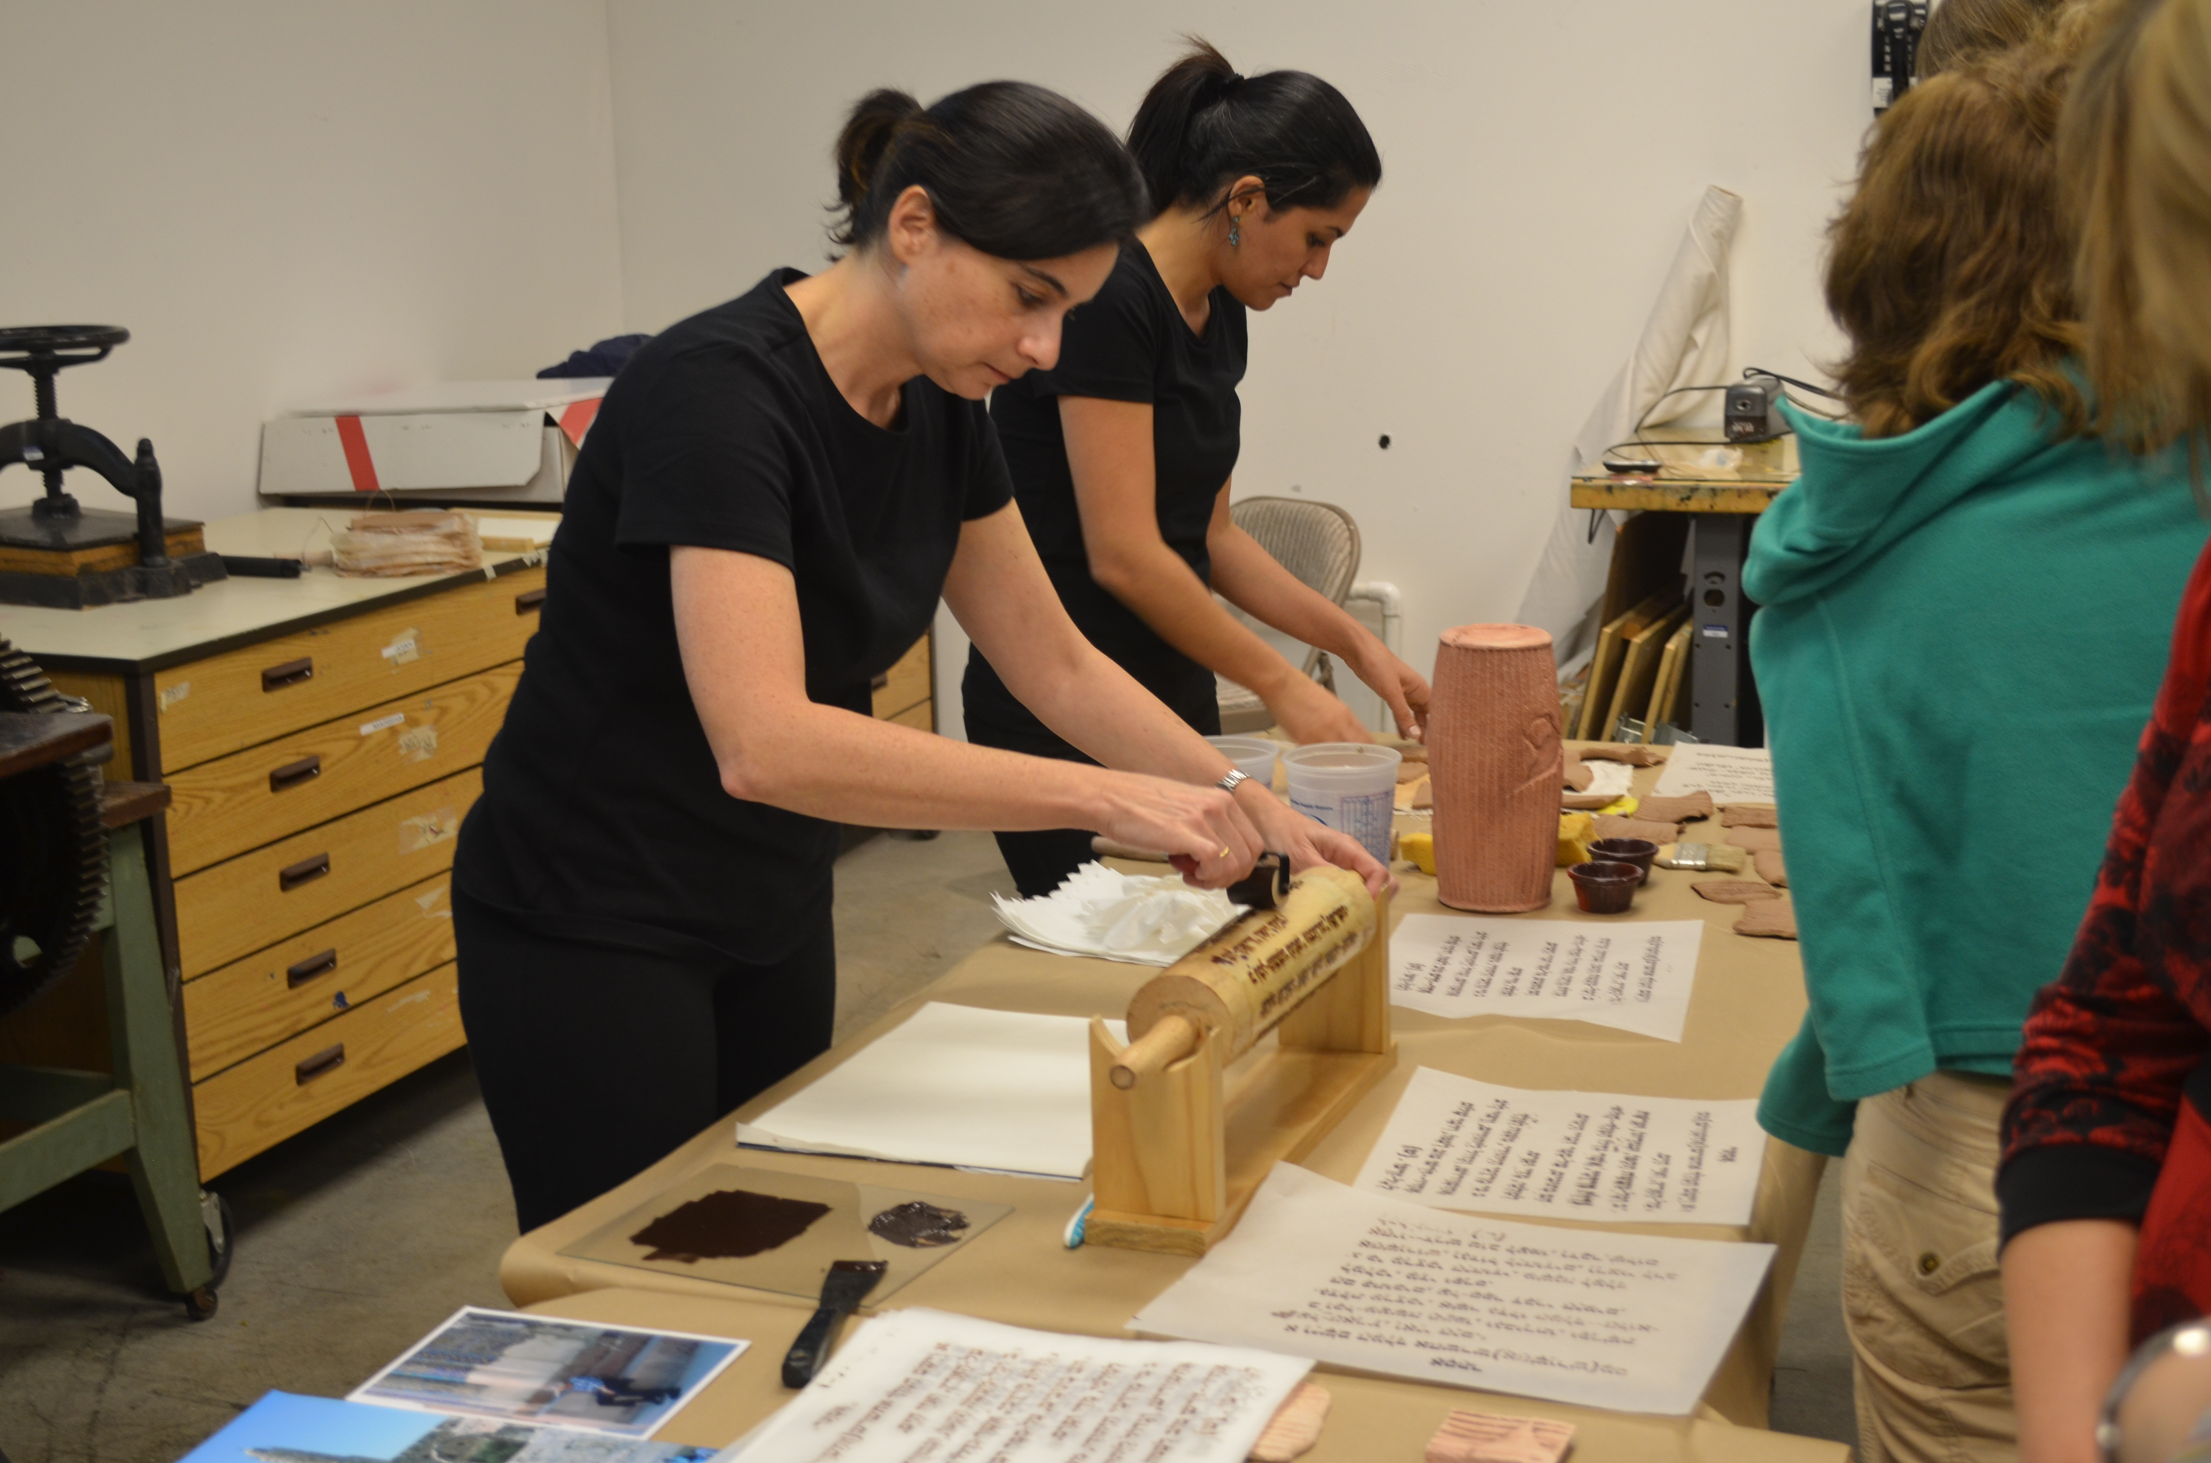
The project will rebuild and refresh the history of the King Cyrus and the Book of Esther.
The Cyrus Cylinder is an ancient clay cylinder inscribed with the first charter of human rights and the Book of Esther or Megiilah Esther is an ancient Jewish story that tells the story of a Jewish girl named Esther who became queen of Persia and frustrated a plan to commit genocide against her people.
The artists, Linda Behar and Raheleh Filsoofi, will create two printmaking cylinders: one in clay and one in wood covered by a polymer plate and use them per formatively to initiate a conversation on peace and conciliation.
The ceramic cylinder will be a barrel-shaped cylinder, measuring 9” by 4” and on the surface the original declaration will be inscribed in cuneiform letters. The wooden roller will be cover by a polymer plate, the dimensions will be 13” by 4” and the Hebrew text will be the last chapter of The Book of Esther built onto the surface.
During each event, the artists will use both cylinders to print the text. The ceramic cylinder will print on a clay slab and the wooden cylinder will print on paper. The printed forms will be gifted to the audience.
The project was conceived by Linda Behar (Jewish immigrant) and Rahele Filsoofi Tavakolnia (Iranian immigrant). Both artists are students in the Master in Fine Art program at Florida Atlantic University. These two artists, with different backgrounds, religions, and nationalities, came together to work in order to convey the universal idea of acceptance.
At this time, peace is a fragile idea and a sense of war is constantly present. The tension between Israel and Iran has intensified. Both artists have family in those countries and are deeply concerned over ongoing tensions and potential conflict. Brought together as colleagues in graduate school, Behar and Tavakolnia, now friends, wonder how conflict will affect their friendship – particularly if family members are hurt in any conflict. Questioning what they could do to communicate a message of tolerance in a world that appears unwilling to compromise, they created this project.
Linda Behar is an artist that specializes in Glass Casting and Printmaking. She has studied and participated in workshops in Venezuela, the U.S. and Italy. Her work had been exhibited in the numerous galleries in Venezuela, Spain and the U.S. Her current contemporary mixed media work subtly employs a variety of techniques to create intrigue and profound meaning that encourages the viewer to search for a spiritual dimension.
Raheleh Filsoofi Tavakolnia received her BFA with a specialization in ceramics from Alzahra University in her native country, Iran. She continued her professional development by assisting several renowned ceramic artists in the United States as well as teaching ceramics for various art organizations. Her art raises awareness of the consciousness, sensitivity and mystery of women and in particular, the aura of Middle Eastern women.
The project brings diverse communities together for conversation and sends a message of tolerance and acceptance to the world.

